|  |  |
| --- | --- |
|  | Student Name ______________________    **Eastern Goldfields College**  Mathematics Essentials 2018  Application 3 – The Great Race  Total Marks: 351 |

This practical application is worth 9% of your course mark. **Equipment needed**: calculator, atlas and additional maps.

The Amazing Race ™ is a reality television programme, in which contestants are required to use their problem solving skills and various modes of transport to race each other to destinations around the world.

For this investigation, you must think like a contestant in The Amazing Race ™. You must plan an itinerary that communicates the time and date of your departure from and arrival to each city you visit. Your itinerary can be written in the table on this page below. As you work through this investigation, return to this table when necessary.

The race starts in Sydney and has three parts;

Part A Sydney to Perth

Part B Perth to Beijing

Part C Beijing to a Mystery City (your final destination)

You have an unlimited budget for flights. Whenever you stop at a location, you must stay there for at least **one hour** before departing (stopover time).

*The winner is determined by the contestant who gets there **first**!!!

The race begins at 2pm on Saturday November the 17th. **Daylight saving in Australia will be in effect at this time.**

On your marks, get set, go!

**Itinerary**

**(18 marks)**

|  |  |  |  |  |  |  |
| --- | --- | --- | --- | --- | --- | --- |
| Flight | From | To | Departure Time  (local time) | Departure Day/Date | Arrival Time  (local time) | Arrival Day/Date |
| 1 | Sydney |  |  |  |  |  |
| 2 |  |  |  |  |  |  |
| 3 |  |  |  |  |  |  |
| 4 |  |  |  |  |  |  |

**Part A - Sydney to Perth**

Your first task is to fly from Sydney to Perth. Unfortunately, due to volcanic ash across South Australia, there are no flights direct from Sydney to Perth. You must fly to Perth from Sydney with a stopover in a different capital city. (Note: Due to the ash there are also no flights in or out of Adelaide).

Create an itinerary for your journey to Perth, and write it in the table on Page 1. Use the space below for working out.

**Part B – Perth to Beijing**

Welcome to Perth! Your next location to get to is Beijing, China. In Perth you catch a private plane that you can fly to Beijing.

In order to get to Beijing, you must determine how much fuel you will need. This will require you to know the distance between Perth and Beijing.

**Question B1 (4 marks)**

Locate both Perth and Beijing (in China), and determine the latitude and longitude of these two cities.

Coordinates of Perth: __________________________________ (Round **UP** to the next degree)

Coordinates of Beijing: __________________________________ (Round to the nearest degree)

**Question B2 (3 marks)**

Use your answers to Question B1 to determine the distance between these two cities. Use radius of the earth as 6370 km.

**Question B3 (2 marks)**

Your plane travels at an average speed of 900 km per hour. How long will it take you to reach Beijing from Perth? **Round your answer to 1 d.p.**

**Question B4 (1 mark)**

Your plane uses 12 litres of fuel per kilometre travelled. How much fuel will be required to get to Beijing?

**Question B5**

Determine the date and time of your arrival in Beijing, and add it to your itinerary on the front page.

**Part C – Beijing to the Mystery City**

In Beijing you are given the coordinates for the Mystery City. It is located at 40.7128° N, 74.0059° W.

**Question C1 (1 mark)**

Use your resources to discover which city can be found at this location.

The Mystery City is: ___________________________________

**Question C2 (4 marks)**

Using the coordinates of Beijing and the mystery city, determine how many hours ahead or behind Coordinated Universal Time (previously known as Greenwich Mean Time or GMT) the local times in these cities are.

Beijing’s local time is ____________ hours ­­­­­­___________ (ahead of/behind) Coordinated Universal Time (GMT)

The Mystery City’s local time is ____________ hours­­­­­­___________ (ahead of/behind) Coordinated Universal Time (GMT)

**Question C3 (2 marks)**

What is the time difference between Beijing and the Mystery City?

**Question C4**

The flight from Beijing to the mystery city takes 13 hours and 25 minutes. This flight crosses the International Date Line. Use this information, and your answer to Question C3 to calculate the relevant times. Update your itinerary on the front page.

END OF TASK

FLIGHTS FROM SYDNEY

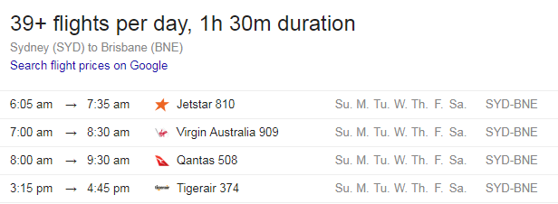

SYDNEY TO BRISBANE:

SYDNEY TO MELBOURNE:

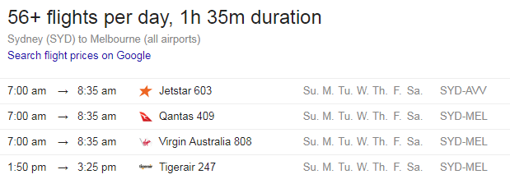

SYDNEY TO DARWIN:

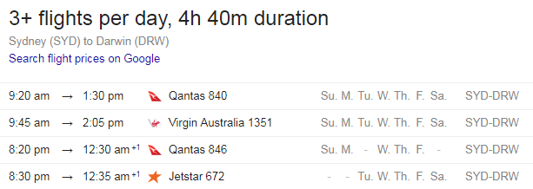

FLIGHTS TO PERTH

BRISBANE TO PERTH:

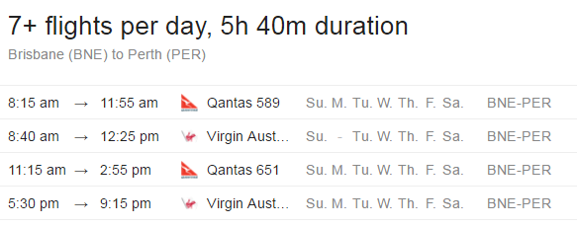

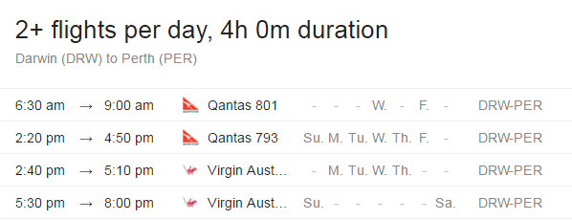

DARWIN TO PERTH:

MELBOURNE TO PERTH:

